

Submitted By:
Ali Zaman– 2026-(S)CYS-35
Assignment:
Lab No. 3
Submitted To:
Sir Mujtaba Kamal

For the fulfillment of,
Programming Fundamental Lab
Department of Computer Engineering
University of Engineering and Technology, Lahore

Task No. 1: Write a program that calculates the permutation and combination of ‘n’ and ‘r’ by using user defined function:

Input :

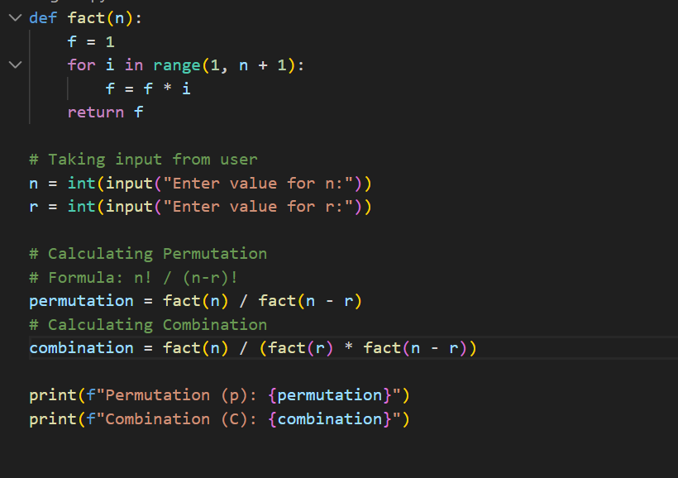

Output :

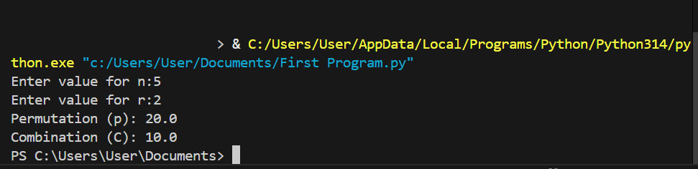

Task No. 2: Write a program that takes two numbers from the user and calculate a large number them using lambda function and then write a UDF that takes that large number from lambda function as an argument and writes its table to a specified range :

Input :

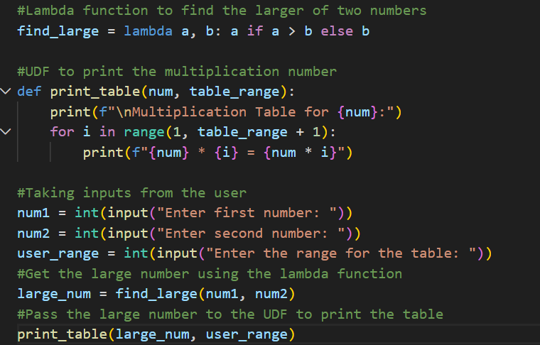

Output :

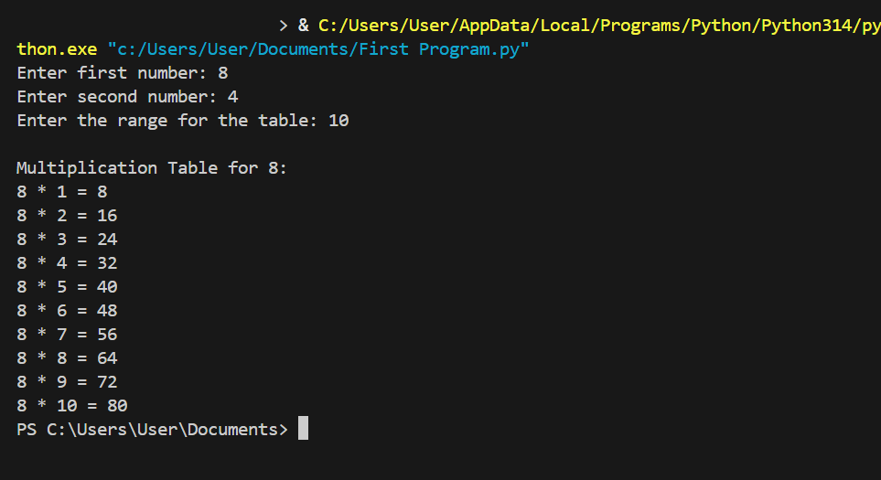

Task No. 3: Write a program that takes a string from user and convert it into a uppercase using lambda function:

Input :

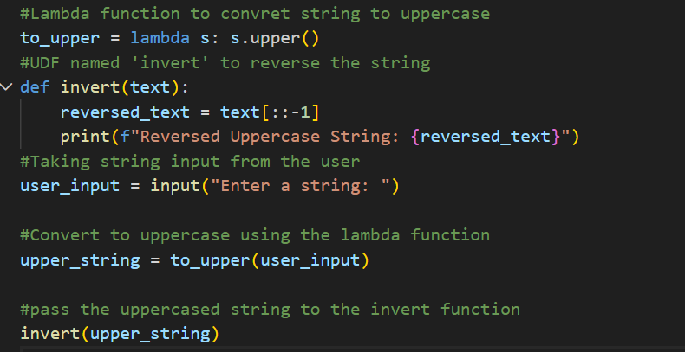

Output :

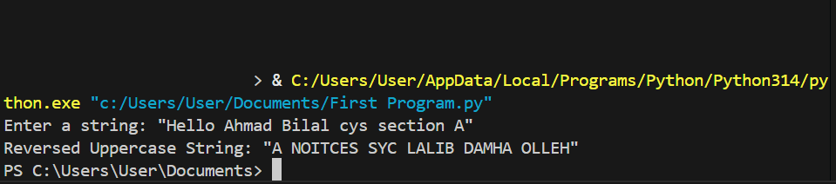

Task No. 4: Write a program that converts Fahrenheit to Celsius and Celsius to Fahrenheit :

Input:

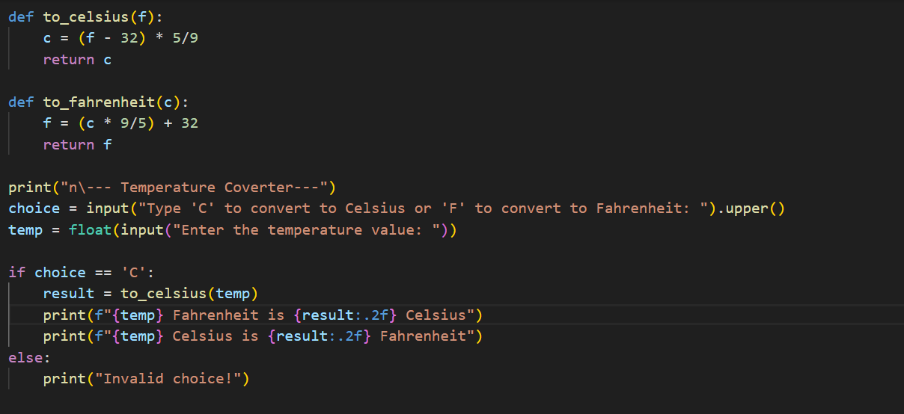

Output :

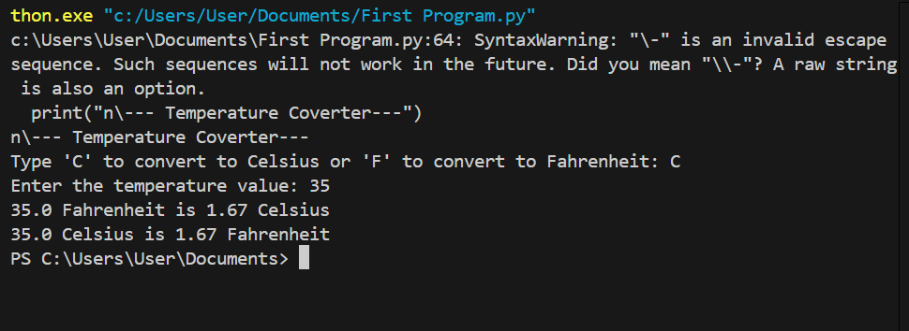

Task No. 5: Write a program to calculate the Grade point average GPA for a semester using user defined function :

Input:

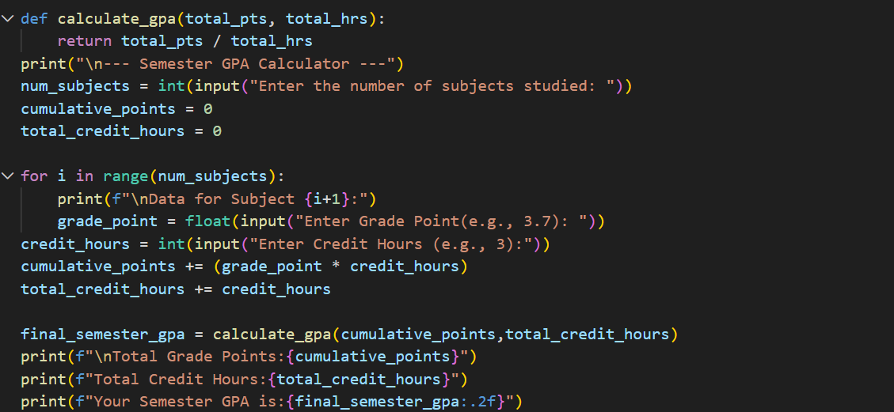

Output :

